INFS 1101 – Lab 8– Basic Python

# Instructions

The lab consists of two parts:

* Part I consists of fundamental exercises: you need to complete, understand, and submit these exercises by midnight.
* Part II consists of additional exercises that you need to finish in the next 3 Days and submit it.

For this lab, you will need to create a flowchart and develop the code for each exercise. The flowchart should be created using draw.io, and the code should be developed in IDLE.

For the coding part, create a new file, and type your code there.

Make sure to include comments in each of your Python files indicating your name, student ID, course and section #, and name of the program.

Once you are done, put all your Python (.py) files in two zipped folders (**Lab8-part1.zip)** and (**Lab8-part2.zip)** , and also save all flowcharts as PNG files, put them in one word file and submit them with the python files on the same D2L dropbox.

Part I

# Exercise 1

Write a program that asks the user to type in the color of the traffic light. If the light is red, the user’s car should stop, if the light is yellow, the user’s car should slow down, and if the light is green, the user’s car should keep going. The user should be able to type the color with any combination of upper/lower case letters with no error message. If the user enters some other color or word, then the entry is not valid. Display an appropriate statement for all the cases mentioned, as shown in the sample runs below (user input in green color).

**Sample 1:**

**What is the color of the traffic light (green/red/yellow)?** **Green**

**Keep going!**

**Sample 2:**

**What is the color of the traffic light (green/red/yellow)?** **red**

**Stop the car!**

**Sample 3:**

**What is the color of the traffic light (green/red/yellow)?** **yeLLOW**

**Slow down!**

**Sample 4:**

**What is the color of the traffic light (green/red/yellow)?** **great**

**This is not a valid entry.**

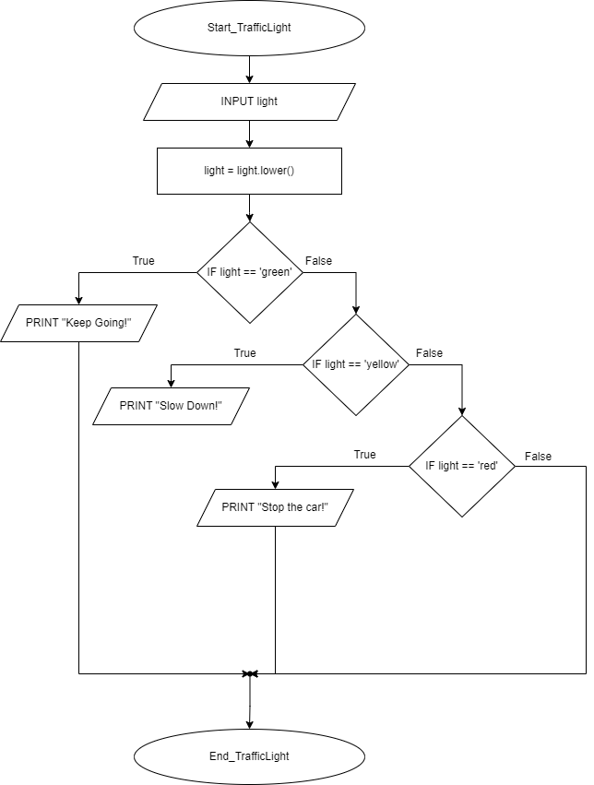

# Exercise 2

Write a program that asks the user to enter their student ID and course code (like INFS1101). Check both the entries for student ID and course code. Student ID should be in the range of (60000000 – 69999999) and course code should be exactly 8 characters long. If any of the user entry is invalid, display an informative error message. If the user entry is valid, display an appropriate message, as shown below in the sample runs (user input in green color).

**Sample 1:**

**Please enter your student ID:** **6009**

**6009 is not a valid entry for student ID. It must be between 60000000 – 69999999.**

**Sample 2:**   
**Please enter your student ID:** **60010999**

**Please enter your course code:** **INF110**

**INF110 is not a valid entry for course code. It must be 8 characters long.**

**Sample 3:**

**Please enter your student ID:** **60098877**

**Please enter your course code:** **INFS1101**

**Thank you for your entry, 60098877. You are now registered in INFS1101.**

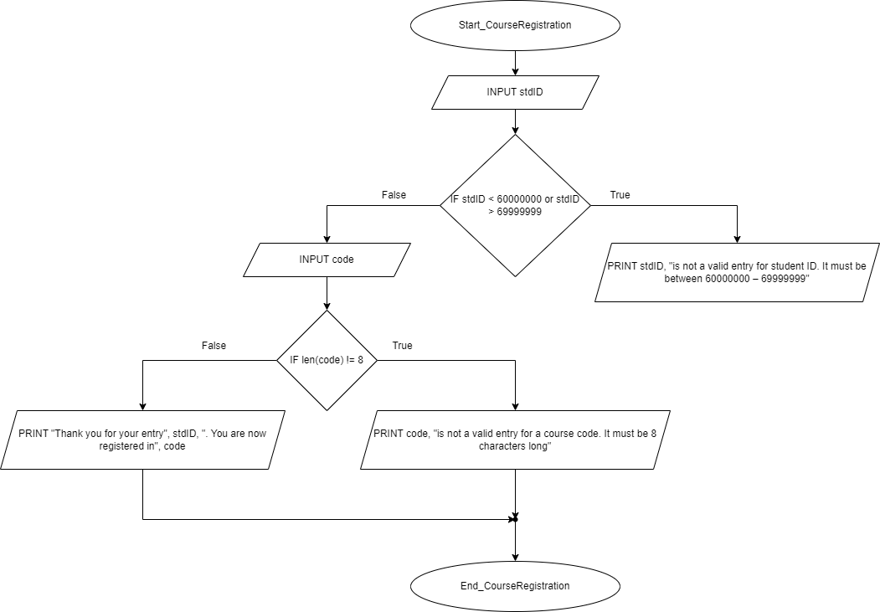

# Exercise 3

Write a program that asks the user to enter their name and year of birth (ex: 1990). Make sure the user entry for name is composed of more than 2 characters, and the user entry for year of birth is between 1900 and 2021. Display an informative error message if the user entry is not valid. If user entries are valid, display a message showing the age of the user, as shown in sample runs below.

**Sample 1:**

**Please enter your name:** **Mi**

**Please enter your entire name.**

**Sample 2:**

**Please enter your name:** **Gerry**

**Please enter your year of birth:** **198**

**This is not a valid entry for year of birth.**

**Sample 3:**

**Please enter your name:** **tom**

**Please enter your year of birth:** **1999**

**Tom, you are 22 years old.**

8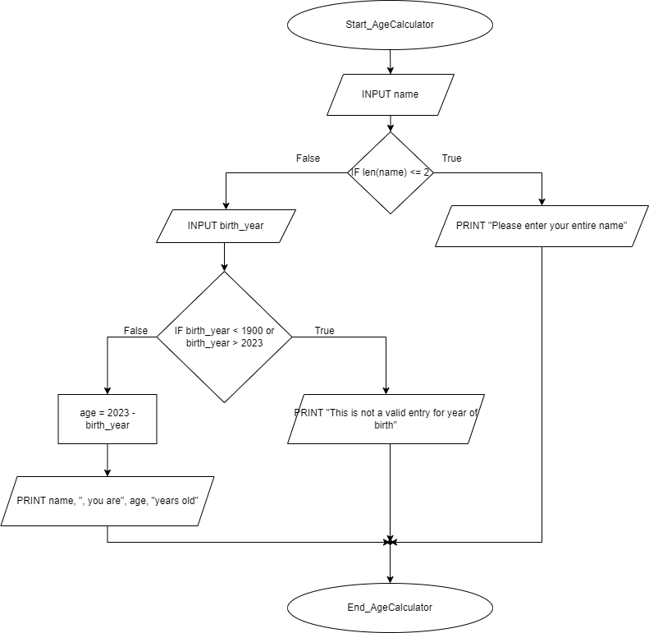

Part II

# Exercise 1

Suppose you shop for rice and find it in two different-sized packages. You would like to write a program to compare the costs of the packages. The program prompts the user to enter the weight and price of each package and then displays the one with the better price. Here is a sample run:

**Sample 1:**

**Enter weight of package 1: 50**

**Enter price of package 1: 24.59**

**Enter weight of package 2: 25**

**Enter price of package 2: 11.9**

**Package 2 the better price.**

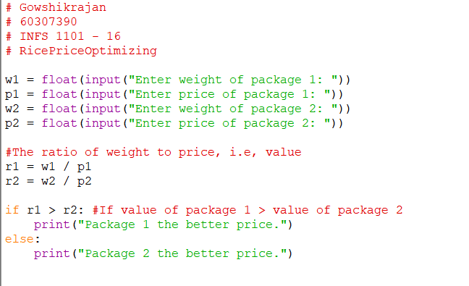

# 

# Exercise 2

Write a program that prompts the user to enter an integer. If the number is a multiple of 5, the program displays the result HiFive. If the number is divisible by 2, the program displays HiEven. Here is a sample run:

**Sample 1:**

**Enter an integer: 4**

**HiEven**

**Sample 2:**

**Enter an integer: 15**

**HiFive**

**Sample 3:**

**Enter an integer: 30**

**HiFive**

**HiEven**

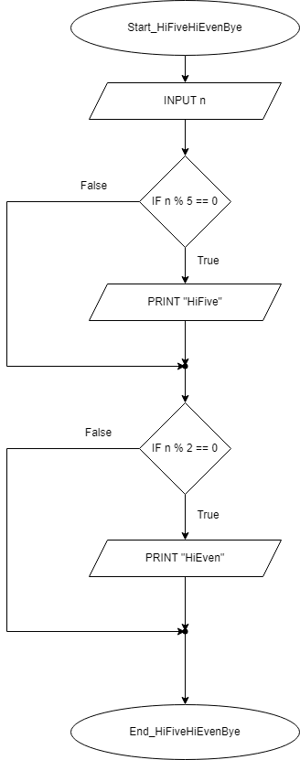

**Remember to include your name, student number, and other relevant information as comments in each of your Python files. Not doing so can result in no grade for that submission.**